COME PROGRAMMARE MEMORIA EPCS4

<https://www.intel.com/content/www/us/en/docs/programmable/683299/current/converting-sof-to-jic-files-in-the-software.html>

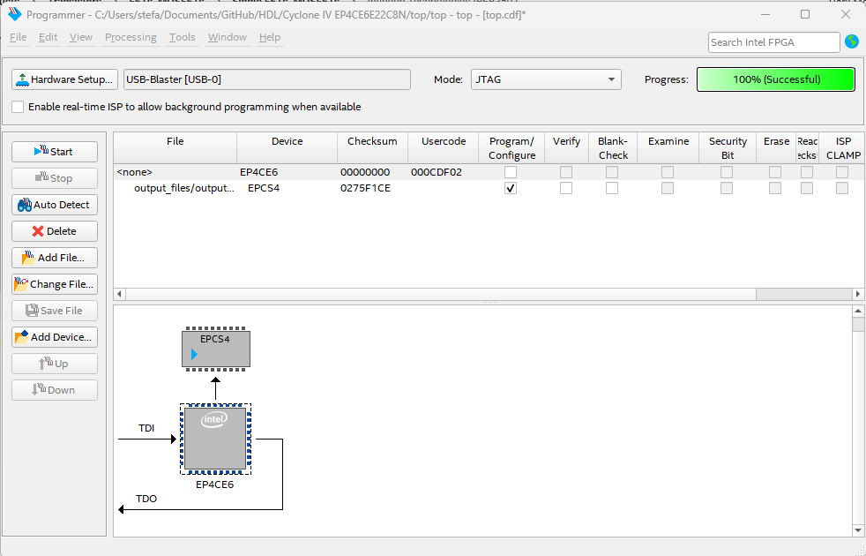

<https://www.eevblog.com/forum/fpga/altera-configuration-flash-crazy-prices-alternatives/>

<https://community.intel.com/t5/Programmable-Devices/EPCS-Discontinuation-looking-for-replacement/td-p/250468>